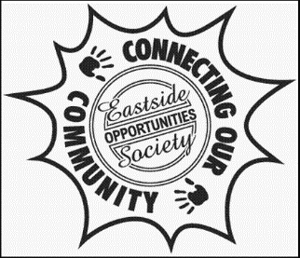
Eastside Opportunities Society
7502 Second Street, Burnaby, BC V3N 3R5
Email: eos.kidslink@gmail.com

Eastside Opportunities Society…………….
….is a non-profit society which operates out of the two portables on the Second Street School playground and at Second Street School
….runs “Kid’s Link Before and After-school Care Program” during the school year for school age children
….hosts an drop in “Youth Night Program” on Tuesday, Thursday and Friday evenings from 7:30-10:00pm in the gym and portable
….is a great place for kids to be during the summer time through the “Summer Fun” day camp program

Eastside Opportunities Society is always seeking interested community members to become a part of the Board to provide input and support on delivering programs and events to meet community needs.

For more information, please contact
Avy Chu at eos.kidslink@gmail.com

